EXPERIMENT 3.1: DSB-SC AND VSB MODULATION

1. AIM
To generate a message signal and carrier signal, perform DSB-SC modulation, obtain a VSB signal using a Butterworth filter, coherently demodulate the signal, and recover the original message signal using MATLAB.

2. APPARATUS / SOFTWARE REQUIRED
- Computer or laptop
- MATLAB software
- MATLAB Editor for entering and running the program

3. THEORY
In DSB-SC modulation, the message signal is multiplied by a carrier signal. The resulting signal contains the upper and lower sidebands but the carrier is suppressed.
Vestigial Sideband (VSB) modulation is obtained by filtering the DSB-SC signal so that one sideband is substantially retained while only a portion (vestige) of the other sideband remains. In this experiment, a Butterworth filter is used as a low-pass approximation for obtaining the VSB signal.
For coherent demodulation, the VSB signal is multiplied by a synchronized carrier. A low-pass Butterworth filter is then used to recover the message signal.

4. MATLAB CODE
clc;
clear;
close all;
% Parameters
fs = 100000; % Sampling Frequency
t = 0:1/fs:0.02; % Time Vector
fm = 500; % Message Frequency
fc = 5000; % Carrier Frequency
% Message Signal
m = cos(2*pi*fm*t);
% Carrier Signal
c = cos(2*pi*fc*t);
% DSB-SC Modulation
dsb = m .* c;
% VSB Filter (Low-pass + High-pass Approximation)
[b,a] = butter(4, fc/(fs/2));
vsb = filter(b,a,dsb);
% Coherent Demodulation
demod = vsb .* (2*cos(2*pi*fc*t));
% Recover Message
[b1,a1] = butter(4, 1000/(fs/2));
rec = filter(b1,a1,demod);
% Display Results
figure;
subplot(5,1,1)
plot(t,m)
title('Message Signal')
grid on
subplot(5,1,2)
plot(t,c)
title('Carrier Signal')
grid on
subplot(5,1,3)
plot(t,dsb)
title('DSB-SC Signal')
grid on
subplot(5,1,4)
plot(t,vsb)
title('VSB Signal')
grid on
subplot(5,1,5)
plot(t,rec,'r')
title('Recovered Message')
grid on

5. MATLAB OUTPUT
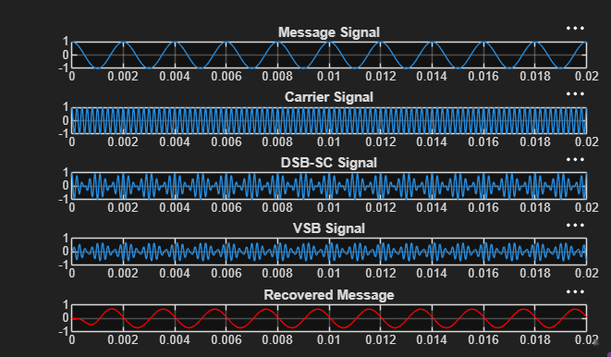
The output shows the Message Signal, Carrier Signal, DSB-SC Signal, VSB Signal, and the Recovered Message in five separate plots.

6. RESULT
The DSB-SC and VSB signals were generated successfully in MATLAB. Coherent demodulation followed by low-pass filtering was used to recover the message signal.

